**Gokul D**

**727722EUCS507**

**Selinium Testing CA – 1**

**QUESTION -1:**

package com.test.ca1;

import org.openqa.selenium.By;

import org.openqa.selenium.WebDriver;

import org.openqa.selenium.chrome.ChromeDriver;

import org.openqa.selenium.chrome.ChromeOptions;

import io.github.bonigarcia.wdm.WebDriverManager;

public class question_1 {

public static void main(String[] args) throws InterruptedException {

ChromeOptions co=new ChromeOptions();

co.addArguments("--remote-allow-origins=*");

WebDriverManager.chromedriver().setup();

WebDriver driver;

driver=new ChromeDriver();

driver.get("https://www.amazon.in/");

driver.manage().window().maximize();

Thread.sleep(4000);

String s = driver.getTitle();

if(s.equals("Online Shopping site in India: Shop Online for Mobiles, Books, Watches, Shoes and More - Amazon.in")) {

System.out.println("Title Matched");

}

driver.findElement(By.xpath("//*[@id=\"twotabsearchtextbox\"]")).sendKeys("iphone 14");

driver.findElement(By.xpath("//*[@id=\"nav-search-submit-button\"]")).click();

Thread.sleep(8000);

driver.findElement(By.xpath("//*[@id=\"search\"]/div[1]/div[1]/div/span[1]/div[1]/div[5]/div/div/div/div/div/div[2]/div/div/div[1]/h2/a/span")).click();

driver.navigate().to("https://www.amazon.in/Apple-iPhone-14-128GB-Midnight/dp/B0BDHX8Z63/ref=sr_1_3_mod_primary_new?crid=2CIR9CN5AYOAW&keywords=iphone%2B14&qid=1683192355&sbo=RZvfv%2F%2FHxDF%2BO5021pAnSA%3D%3D&sprefix=ip%2Caps%2C2878&sr=8-3&th=1");

Thread.sleep(30000);

driver.findElement(By.xpath("//*[@id=\"add-to-cart-button\"]")).click();

Thread.sleep(4000);

String cart = driver.findElement(By.xpath("//*[@id=\"attachDisplayAddBaseAlert\"]/span")).getText();

if(cart.equals("\r\n"+ " Added to Cart")) {

System.out.println("Item added to cart");

}

driver.findElement(By.xpath("//*[@id=\"attach-sidesheet-view-cart-button\"]/span/input")).click();

Thread.sleep(4000);

driver.findElement(By.xpath("//*[@id=\"quantity\"]")).click();

driver.findElement(By.xpath("//*[@id=\"quantity\"]/option[3]")).click();

String qty = driver.findElement(By.xpath("//*[@id=\"sc-active-C31dc03a0-1c79-4522-806b-323b615f7a09\"]/div[4]/div/div[3]/div[1]/span[1]/span/span[1]/span/span/span/span/span[2]")).getText();

if(qty.equals("2")) {

System.out.println("Quantity sucessfully updated");

}

driver.findElement(By.xpath("//*[@id=\"sc-buy-box-ptc-button\"]/span")).click();

Thread.sleep(4000);

String price = driver.findElement(By.xpath("//*[@id=\"subtotals-marketplace-table\"]/tbody/tr[4]/td[2]")).getText();

if(price.equals("\r\n"

+ " \r\n"

+ " \r\n"

+ " \r\n"

+ " ₹67,999.00\r\n"

+ " \r\n"

+ " \r\n"

+ " ")) {

System.out.println("Price Matched accurately");

}

driver.navigate().back();

Thread.sleep(4000);

driver.findElement(By.xpath("//*[@id=\"sc-active-31dc03a0-1c79-4522-806b-323b615f7a09\"]/div[4]/div/div[3]/div[1]/span[2]/span/input")).click();

Thread.sleep(3000);

String delete = driver.findElement(By.xpath("//*[@id=\"sc-active-cart\"]/div/div[1]/div/h1")).getText();

if(delete.equals("\r\n"

+ "Your Amazon Cart is empty.")) {

System.out.println("Item deleted sucessfully");

}

driver.close();

}

}

}

**}OUTPUT:**

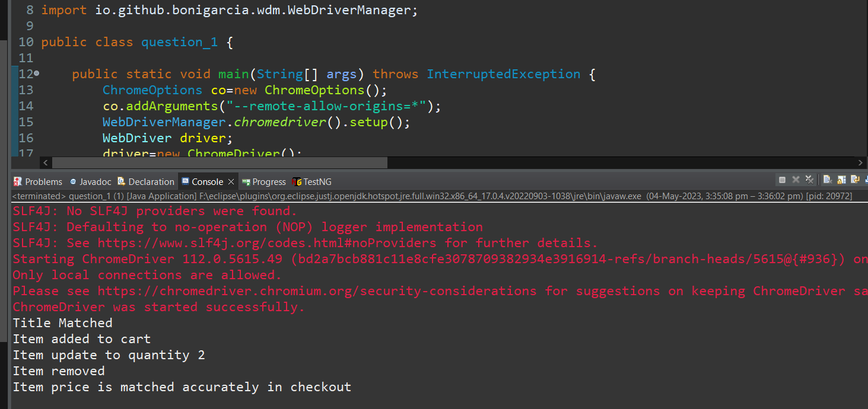

**QUESTION -2:**

package com.test.CA1;

import org.openqa.selenium.By;

import org.openqa.selenium.WebDriver;

import org.openqa.selenium.WebElement;

import org.openqa.selenium.chrome.ChromeDriver;

import org.openqa.selenium.chrome.ChromeOptions;

import io.github.bonigarcia.wdm.WebDriverManager;

public class Ce_2 {

public static void main(String[] args) {

ChromeOptions co=new ChromeOptions();

co.addArguments ("--remote-allow-origins=*");

WebDriverManager.*chromedriver*().setup ();

WebDriver driver=new ChromeDriver(co);

driver.get ("https://www.amazon.in/");

driver.manage().window().maximize() ;

String currentTitle=driver.getTitle();

System.***out***.println(currentTitle);

String expectedTitle="Online Shopping site in India: Shop Online for Mobiles, Books, Watches, Shoes and More - Amazon.in";

if(currentTitle.equals(expectedTitle)) {

System.***out***.println("Title Matched");

}

else {

System.***out***.println("Title not Matched");

}

WebElement txtBoxl=driver.findElement(By.*xpath*("//*[@id=\"twotabsearchtextbox\"]"));

txtBoxl.sendKeys("macbook");

driver.findElement(By.*xpath*("//*[@id=\"nav-search-submit-button\"]")).click();

String txt1=driver.findElement(By.*xpath*("//*[@id=\"search\"]/div[1]/div[1]/div/span[1]/div[1]/div[3]/div/div/div/div/div/div/div/div[2]/div/div/div[1]/h2/a/span")).getText();

System.***out***.println(txt1);

String txt2=driver.findElement(By.*xpath*("//*[@id=\"search\"]/div[1]/div[1]/div/span[1]/div[1]/div[4]/div/div/div/div/div/div/div/div[2]/div/div/div[1]/h2/a/span")).getText();

System.***out***.println(txt2);

String txt3=driver.findElement(By.*xpath*("//*[@id=\"search\"]/div[1]/div[1]/div/span[1]/div[1]/div[5]/div/div/div/div/div/div[2]/div/div/div[1]/h2/a/span")).getText();

System.***out***.println(txt3);

String txt4=driver.findElement(By.*xpath*("//*[@id=\"search\"]/div[1]/div[1]/div/span[1]/div[1]/div[6]/div/div/div/div/div/div[2]/div/div/div[1]/h2/a/span")).getText();

System.***out***.println(txt4);

String txt5=driver.findElement(By.*xpath*("//*[@id=\"search\"]/div[1]/div[1]/div/span[1]/div[1]/div[7]/div/div/div/div/div/div[2]/div/div/div[1]/h2/a/span")).getText();

System.***out***.println(txt5);

//filter

driver.findElement(By.*xpath*("//*[@id=\"p_36/7252032031\"]/span/a/span")).click();

driver.findElement(By.*xpath*("//*[@id=\"p_n_pattern_browse-bin/1464446031\"]/span/a/span")).click();

}

**OUTPUT:**

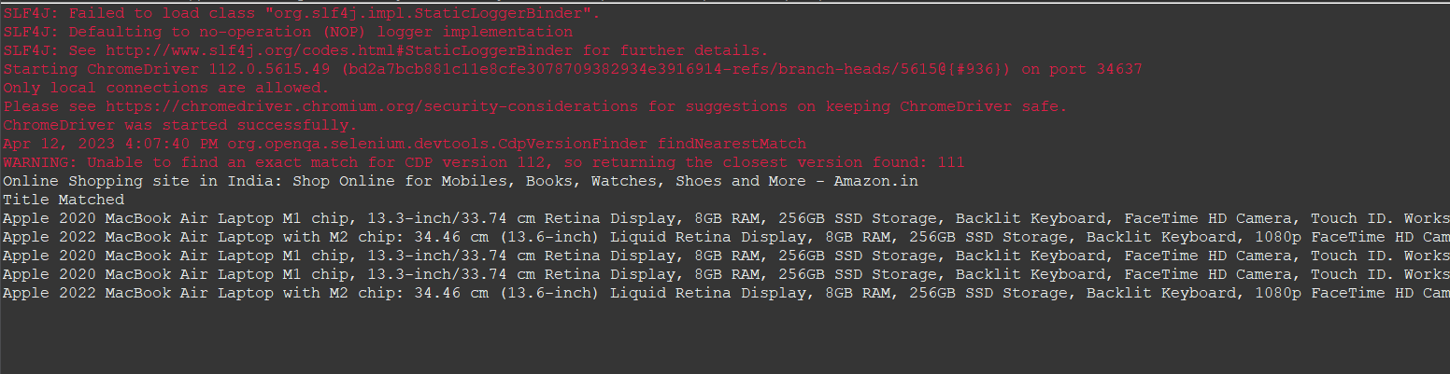

**QUESTION -3:**

package com.test.CA1;

import org.openqa.selenium.By;

import org.openqa.selenium.WebDriver;

import org.openqa.selenium.WebElement;

import org.openqa.selenium.chrome.ChromeDriver;

import org.openqa.selenium.chrome.ChromeOptions;

import io.github.bonigarcia.wdm.WebDriverManager;

public class Ce_3 {

public static void main(String[] args) {

ChromeOptions co=new ChromeOptions();

co.addArguments ("--remote-allow-origins=*");

WebDriverManager.*chromedriver*().setup ();

WebDriver driver=new ChromeDriver(co);

driver.get ("https://www.amazon.in/");

driver.manage().window().maximize() ;

String currentTitle=driver.getTitle();

System.***out***.println(currentTitle);

String expectedTitle="Online Shopping site in India: Shop Online for Mobiles, Books, Watches, Shoes and More - Amazon.in";

if(currentTitle.equals(expectedTitle)) {

System.***out***.println("Title Matched");

}

else {

System.***out***.println("Title not Matched");

}

driver.findElement(By.*xpath*("//*[@id=\"nav-link-accountList\"]")).click();

WebElement txtBoxl=driver.findElement(By.*xpath*("//*[@id=\"ap_email\"]"));

txtBoxl.sendKeys("9677904185");

driver.findElement(By.*xpath*("//*[@id=\"continue\"]")).click();

WebElement txtBox2=driver.findElement(By.*xpath*("//*[@id=\"ap_password\"]"));

txtBox2.sendKeys("shankar@3002");

driver.findElement(By.*xpath*("//*[@id=\"signInSubmit\"]")).click();

driver.findElement(By.*xpath*("//*[@id=\"nav-link-accountList\"]")).click();

driver.findElement(By.*xpath*("//*[@id=\"a-page\"]/div[2]/div/div[2]/div[1]/a/div/div")).click();

driver.findElement(By.*xpath*("//*[@id=\"a-autoid-2-announce\"]")).click();

driver.findElement(By.*xpath*("//*[@id=\"ordersInPackage-container\"]/div/div/a[1]")).click();

**OUTPUT:**

